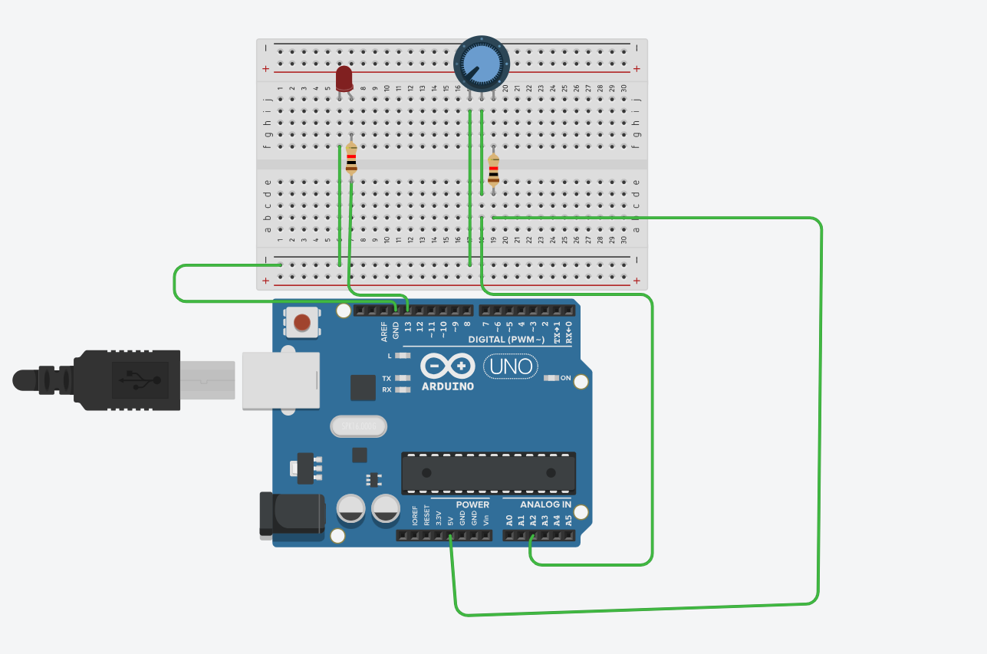

Code:- int potPin = A2; // Pin for the potentiometer
int ledPin = 13; // Pin for the LED

void setup() {
Serial.begin(9600); // Initialize serial communication at 9600 baud
pinMode(ledPin, OUTPUT); // Set LED pin as an output
}

void loop() {
int potValue = analogRead(potPin); // Read the potentiometer value (0 to 1023)

Serial.print("POT: ");
Serial.println(potValue); // Print potentiometer value to the serial monitor

// Control the LED based on potentiometer value
if (potValue > 512) { // If the potentiometer is turned above halfway
digitalWrite(ledPin, HIGH); // Turn the LED on
} else {
digitalWrite(ledPin, LOW); // Turn the LED off
}

delay(100); // Small delay for stability
}

